**STUDENTS:**

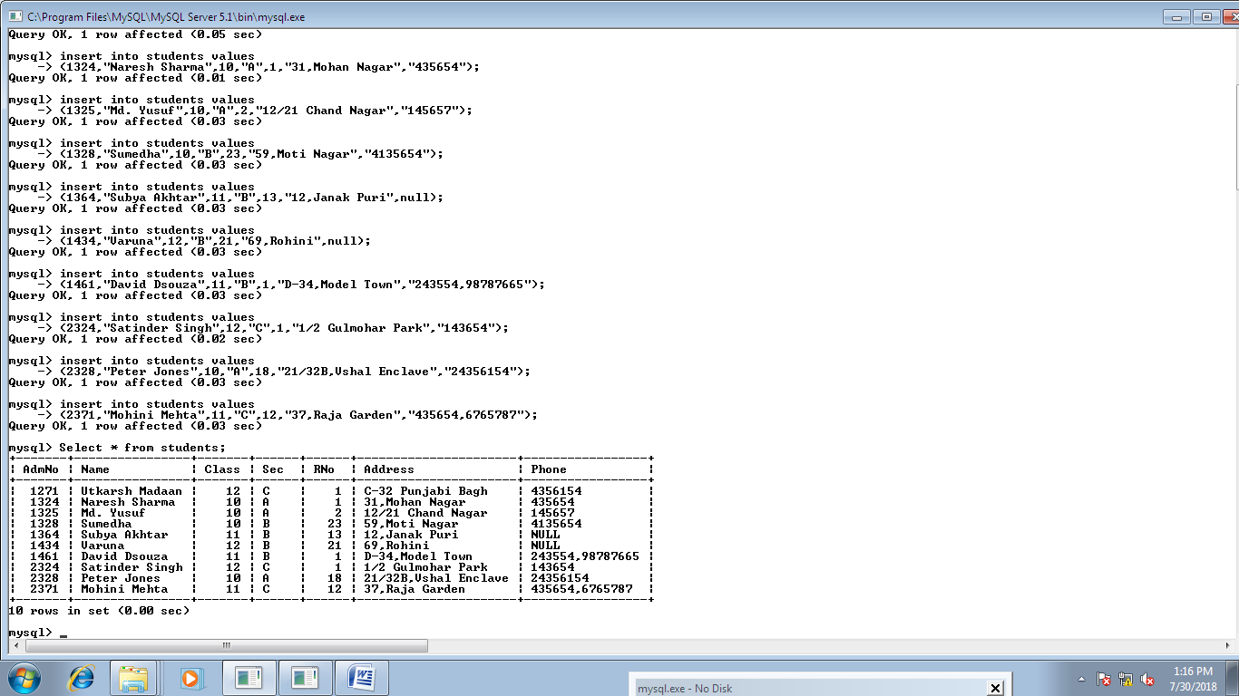

**SPORTS:**

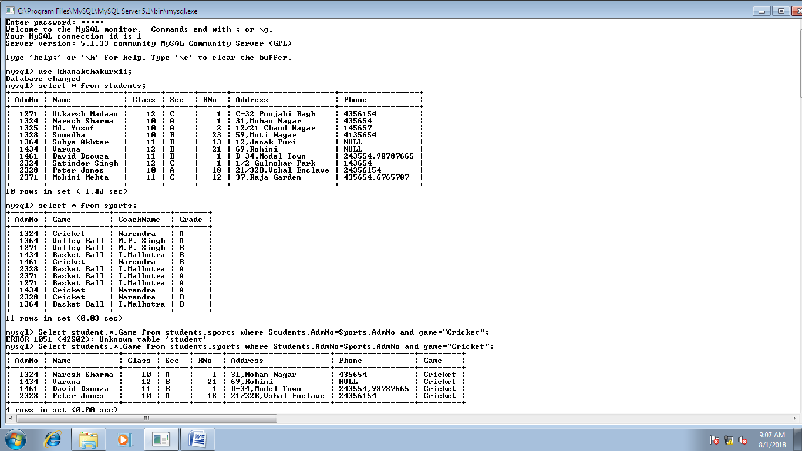

**QUERIES:**

1. Create table Students.
2. Show the structure of the students table.
3. Create table Sports.
4. Show the structure of the table Sports.
5. Display the lowest and the highest classes from the table.
6. Display the number of students in each class from the students.
7. Display the number of students in class 10.
8. Display the details of the students of cricket team.
9. Display Adm. Number, Name, Class, Section and Roll number of the students whose grade in sports table is A.
10. Display name and phone number of students of class 12 who play some game.
11. Display the number of students with each coach.
12. Display names and phone numbers of students whose grade is A and whose coach is Narendra.

**1.**

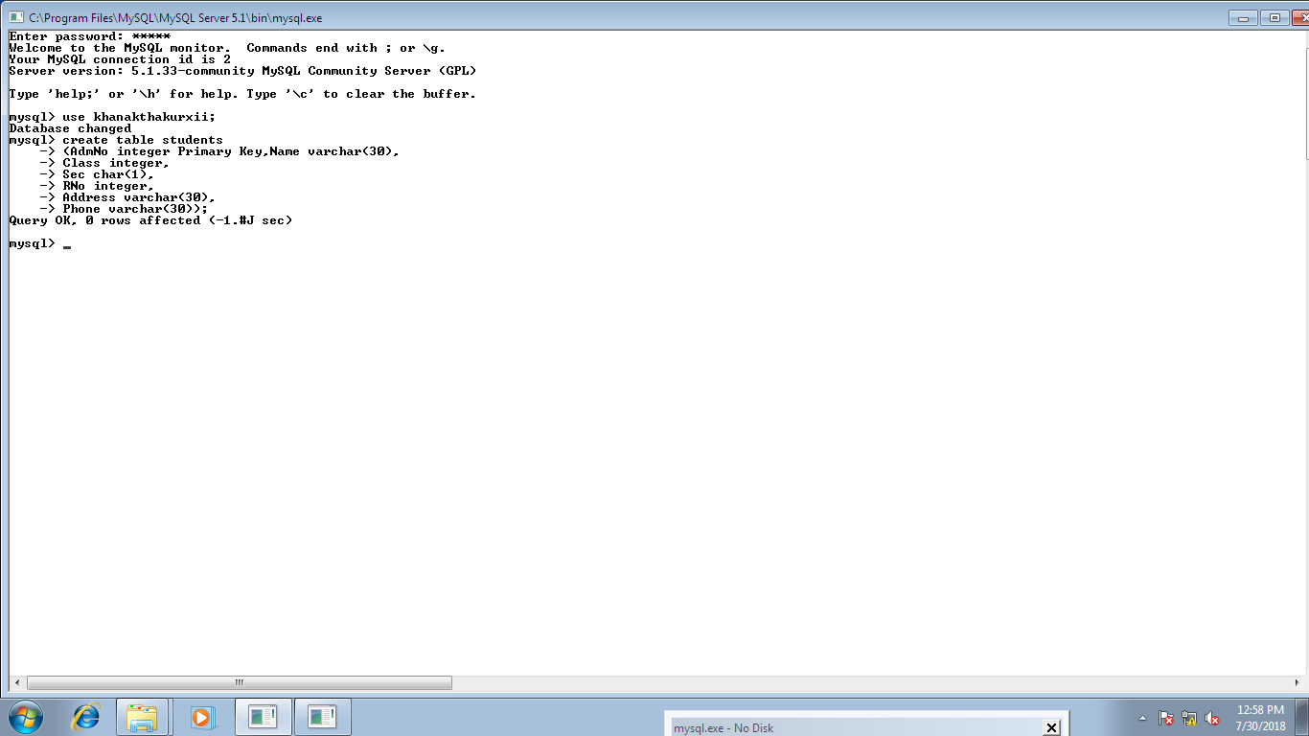

**2.**

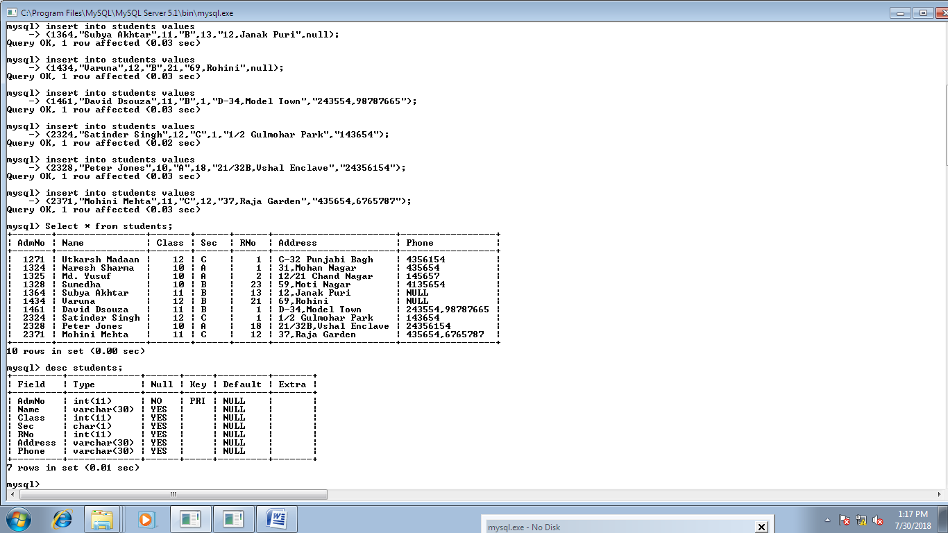

**3.**

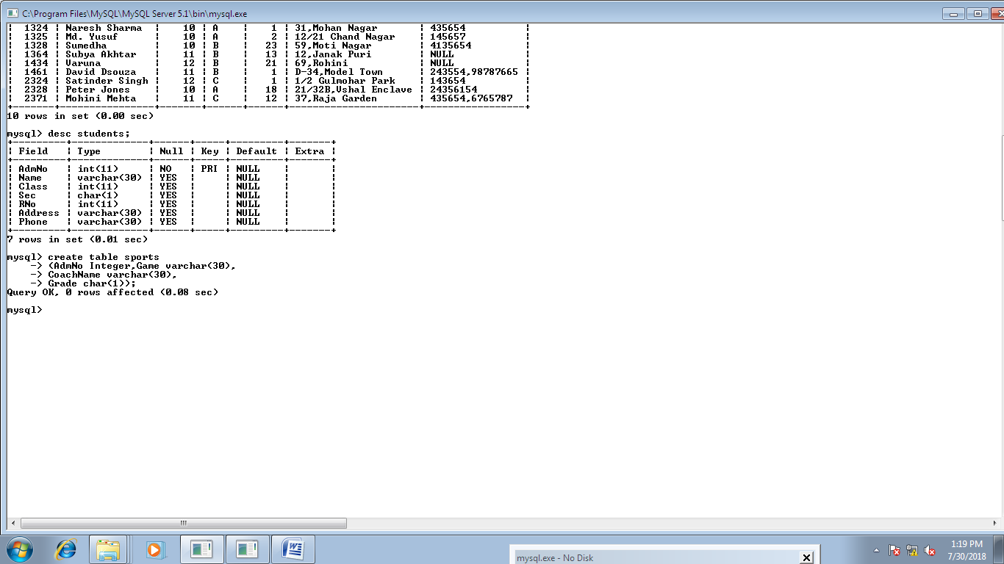

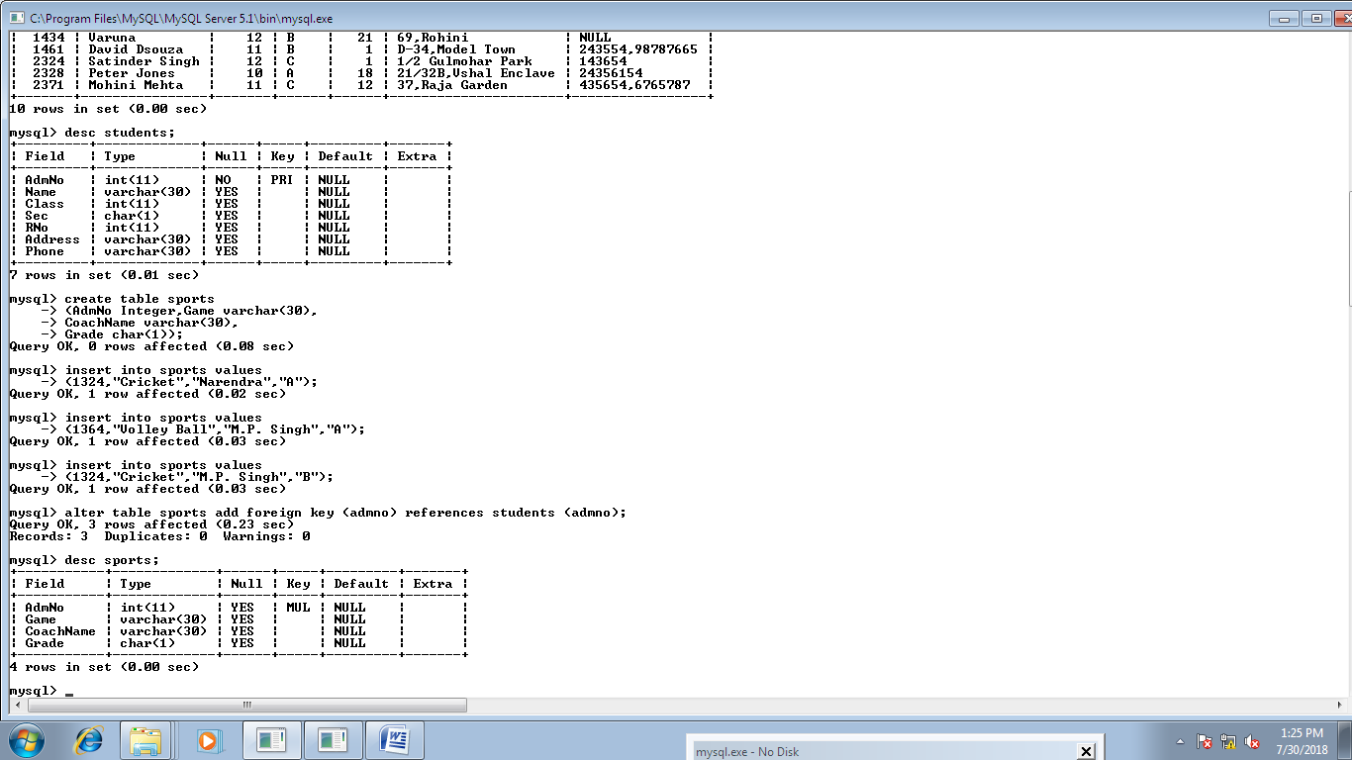

**4.**



**5.**

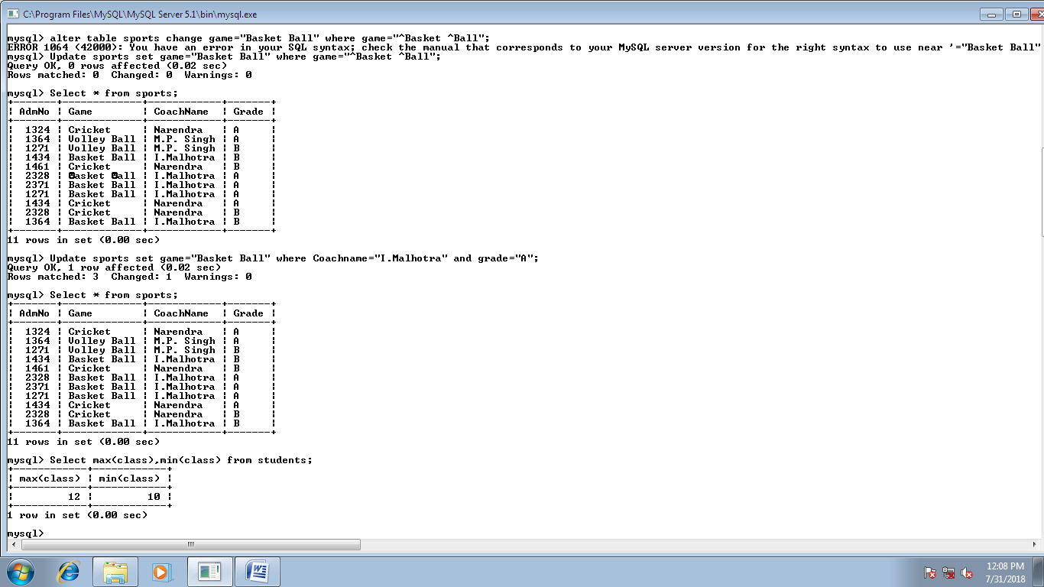

**6.**

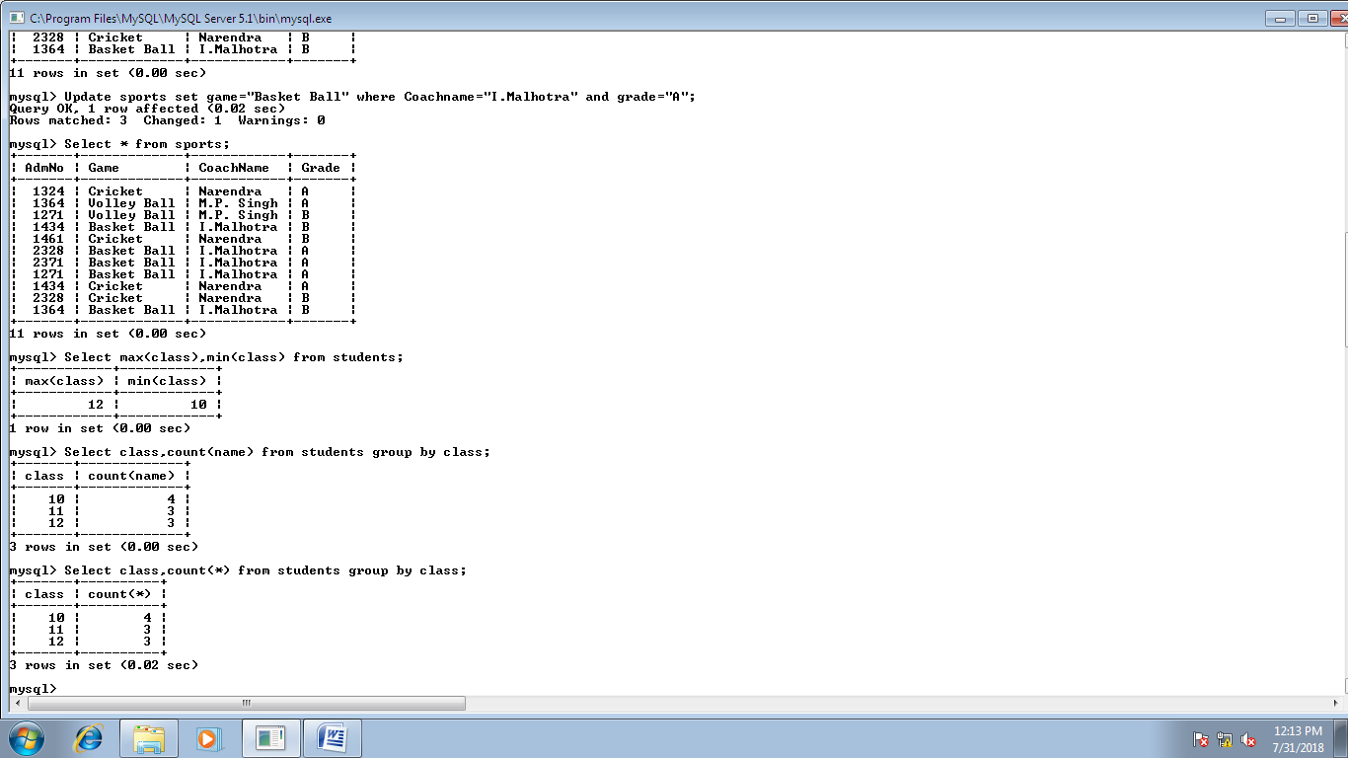

**7.**

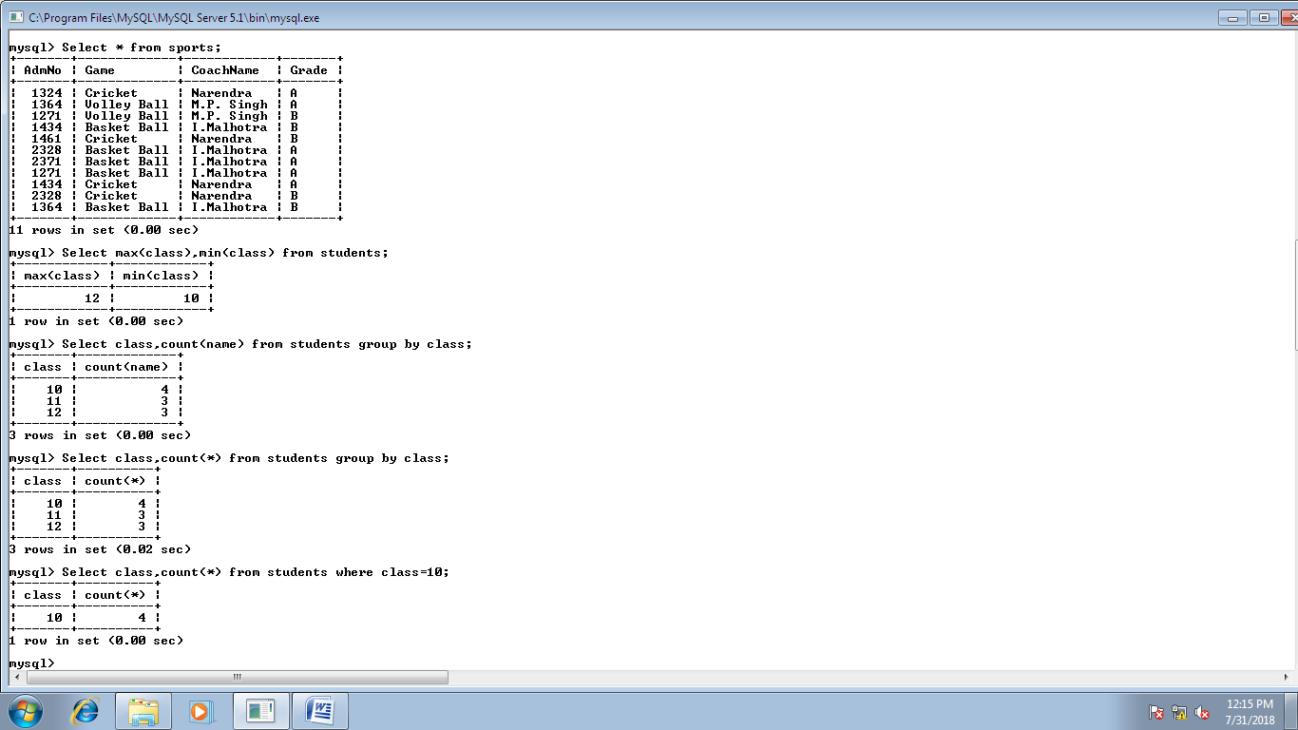

**8.**

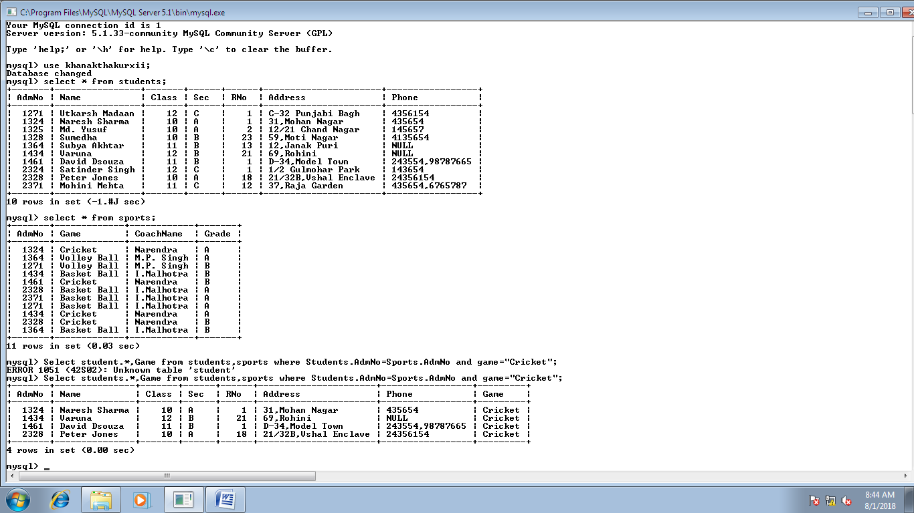

**9.**

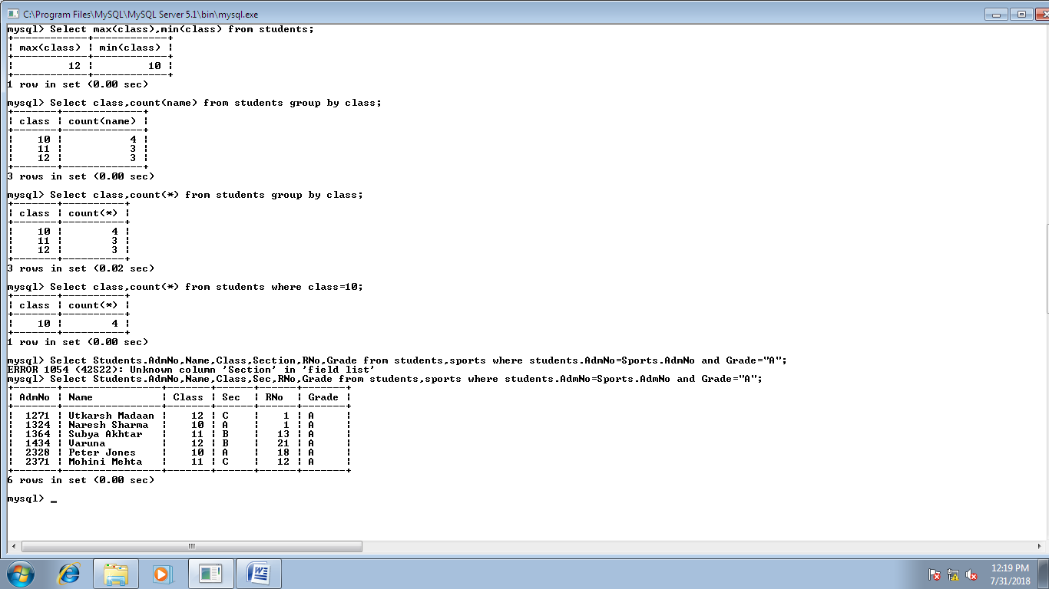

**10.**

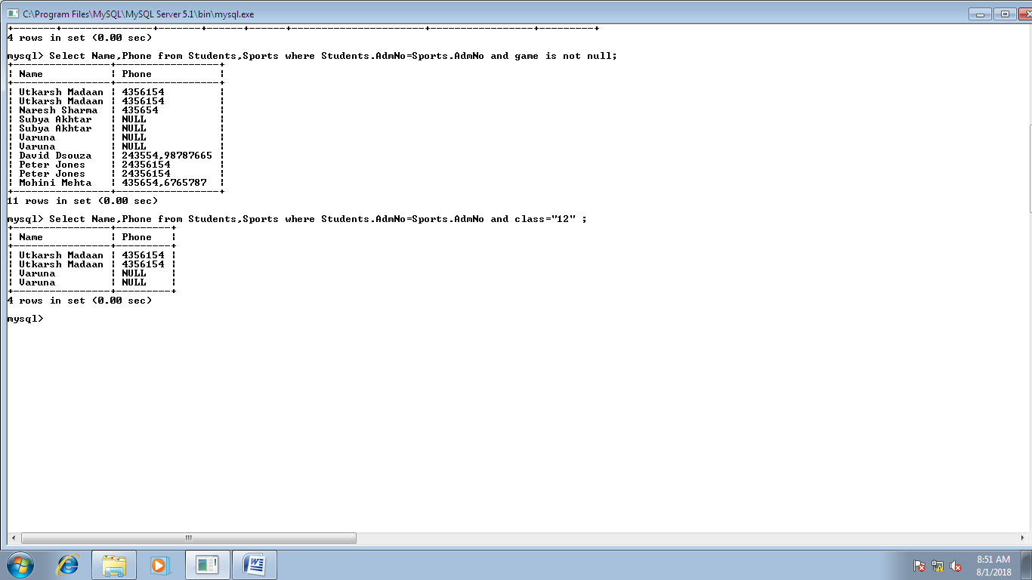

**11.**

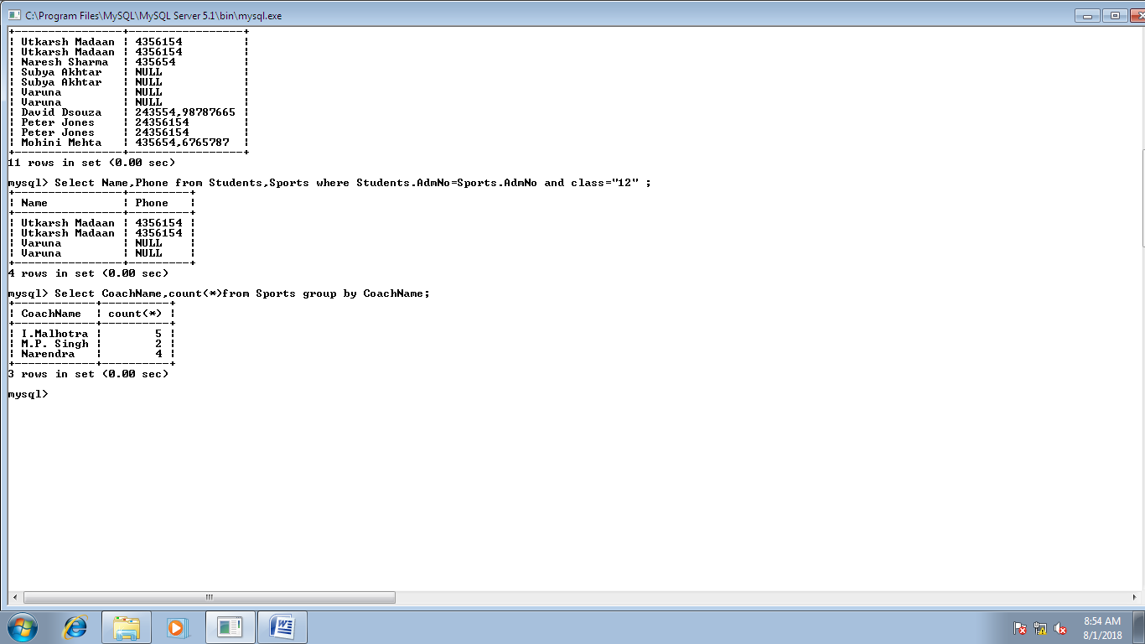

**12.**

